Geogebra Lesson: Angle pairs formed by parallel lines cut by a transversal

Grades: 8-10

You want to create two parallel lines and a transversal line through both the lines.

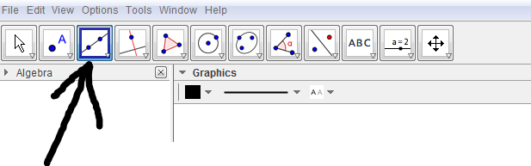
Click on the line button

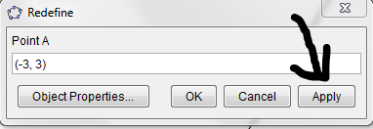
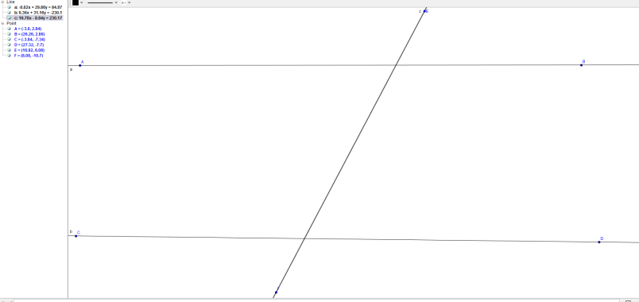
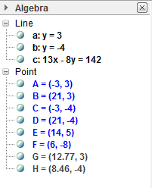
Create your lines to be as parallel as possible. After creating your lines you can edit your points to make them exactly parallel by double clicking on point A, B, C, and D.

  - Redefine your points then click apply
- As shown on the graph there are eight angles created by the transversal. Name those angles

1._ex. AGE_________ 5.__________________
2._________________ 6.__________________
3._________________ 7.__________________
4._________________ 8.__________________
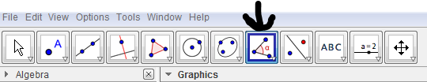
- Now using the angle button pick anyone of your angles and figure out what it is

  - Pick any three points that make an angle

- Now knowing that a line is 180, and that when angles add together they make a circle that 360, use the angle that you found to find all the other angles.
1____________ 2_____________ 3______________ 4_____________
5____________ 6_____________ 7______________ 8_____________

- After finding all the angles, some similarities shown appear between the angles. Which of the angles are congruent to each other?

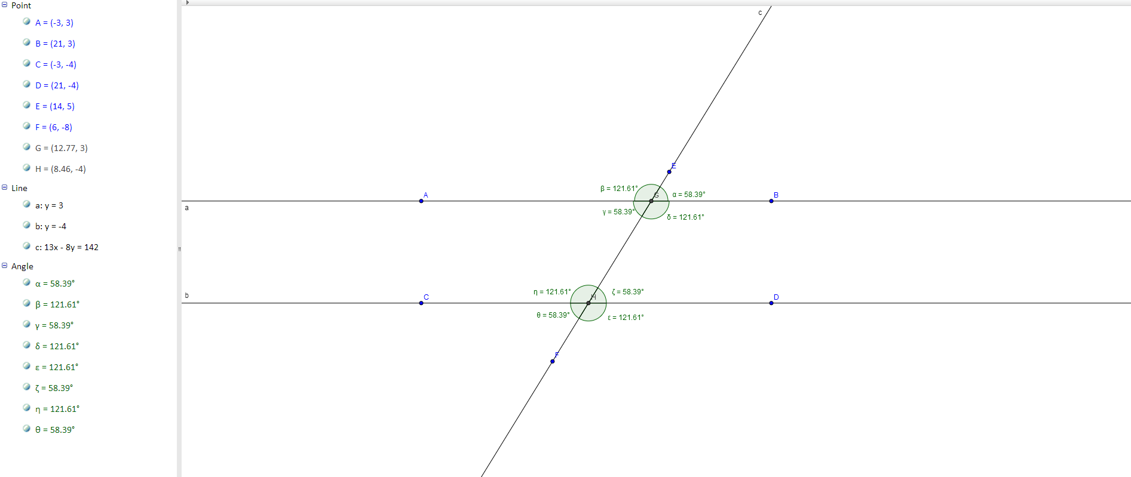
- After finding all the congruent angles you can go back to geogebra and use the angle button for the rest of them to get a visual of all the congruent angles.

